INTERNATIONAL CONFERENCE
"European Defense - the way forward"

The European Union faces various threats, including terrorism, uncertainties on its periphery, uncontrolled migration, cyber-threats and many others. This leads most Europeans to believe that the EU needs to invest more in building its common security and defense.
In recent years, serious progress has been made in the construction of European defense, like the establishment of the Military Planning and Conduct Capability, Permanent Structured Cooperation (PESCO), European Defense Action Plan, European Defense Fund (EDF) and more.
Along with success, there are many questions that give rise to uncertainty. Will the efforts to find common solutions to common risks continue, will we see “different speeds” in the development of the European security and defense, what will be the impact of Brexit, what is the place of NATO and the US in European defense and many others?
Whether the efforts to build a stronger European defense will continue, at what speed and in what direction it will depend on the policies and views of individual countries but also on the common EU bodies. That is why elections to the European Parliament in 2019 are key to the security of the Union and its citizens.
To analyze the security risks and challenges which Europe faces with but also the future steps that are needed to protect the member-states and European citizens Sofia Security Forum and the Konrad Adenauer Foundation are organizing an international conference "European Defense - the way forward".

Learn more from the Bulgarian Politicians from different political spectra and prominent international analysts.


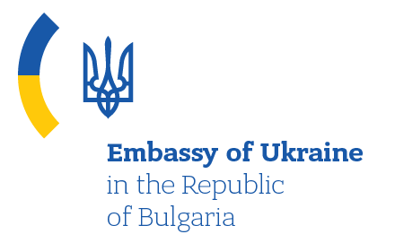

INTERNATIONAL CONFERENCE
Under the Patronage of the Chairman of the Defense Committee of the National Assembly of the Republic of Bulgaria Gen. (ret.) Constantin Popov

"European Defense - the way forward"
23 April 2019
Central Military Club, Sofia Bulgaria
Working languages: Bulgarian and English (simultaneous translation)

09:00 – 09:30 Registration and coffee

09:30 – 09:45 Opening
– “Working together to make our Europe more secure.”
Thorsten Geißler, Director, Sofia Office of the Konrad
Adenauer Foundation
Yordan Bozhilov – President of Sofia Security
Forum
09:45 – 10:00 Keynote address:
Gen. /ret./ Constantin Popov, Chairman of the Defense
Committee, Bulgarian Parliament (Confirmed)

10:00 – 11:00 First Panel: The European Defense: Bulgarian perspective(s)
Dr. Georgi Krastev, National Security Adviser to the Prime Minister of Bulgaria. (Confirmed)
Col. Nikolay Nikolov, Deputy National Armament Director, MOD, Bulgaria
Boyko Noev, Minister of Defense (1994 – 1995), (1999 – 2001)
Angel Naydenov, Minister of Defense (2013 – 2014)

Q&A

Moderator: Ms. Monika Panayotova, Vice-President,
Sofia Security Forum

11:00 – 11:30 Coffee - break

11:30 – 13:30 Second Panel “Europe between the risks and
Opportunities, ideas and realities”

Presentations by:
Mr. Heinrich Brauss, German Council on Foreign Relations, former Assistant NATO Secretary General (Confirmed)
Oleksandr Khara, Maidan of Foreign Affairs, Ukraine (Confirmed)
Iulian Chifu, Director, Centre for Early Warning and Conflict Prevention, Romania. (Confirmed)
Velizar Shalamanov, (Confirmed)

Q&A

Moderatior: Mr. Yordan Bozhilov, President, Sofia Security Forum

13:30 – LUNCH

SPEAKERS:

General (ret.) Constantin Popov
Chairman of the Defense Committee and member of the Committee on Internal Security and Public Order of the 44th National Assembly of the Republic of Bulgaria

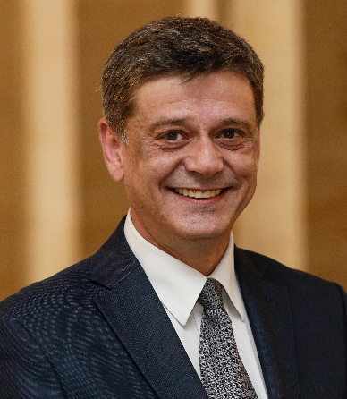
General Constantin Popov was born in 1961 in Sofia. During his military career he has gone from junior pilot in a fighter squadron, Commander of a fighter air base, through Commander of the Air Force and Deputy Chief of Defense to Chief of Defense of the Republic of Bulgaria.
He has over 1200 flight hours on L-29, MiG-15, MiG-17, MiG-21, MiG-29.
General Popov is one of the first senior Bulgarian officers who worked in a NATO HQ. He was Chief of Staff, NATO Joint Force Training Centre in Bydgoszcz, Poland in the period 2005 – 2006. From 2006 to 2008 he was assigned Deputy Chief of Staff of the Allied Air Component Command Headquarters, Izmir, Turkey.
General Popov was elected to the Bulgarian Parliament in April 2017 upon his retirement of active service.
General Popov holds a Master’s Degree in Strategic Studies from Air War College, Maxwell Air Force Base, Alabama, USA and a Ph.D. in Organization and Management of the Armed Forces from “G.S. Rakovski” National Defense College, Sofia. He is also a Member of the Union of Scientists in Bulgaria.
His national decorations include, inter alia, the order “Stara Planina” – first grade, with swords, the Medal of Honor “St. George the Victor”– first grade, the “Commendation Medal for Meritorious Service under the Colors”, the “Commendation Medal for Contribution to the Ministry of Defense”, awarded to him for his distinguished service and professional achievements.
In recognition of his work in Bydgoszcz he was awarded the “Golden medal of the Polish Armed Forces”.
General Popov is married to Liliya and they have three grown-up children – a daughter and twin boys. He enjoys reading history books.

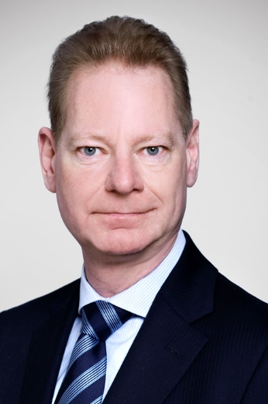
Thorsten Geissler

Since 01-04-2016 Thorsten Geissler is Director, Bulgaria Office, Konrad Adenauer Foundation.
Between 01-12-10 and 29-02-16 he was Director Rule of Law Program South East Europe.
He is an Employee Konrad-Adenauer-Foundation since 01.09.2010.
In the time from 01.05.2004 until 30.04.2010 Geissler was Senator for Environment, Security, and Public Order and Second Deputy Mayor of the Hanseatic City of Lübeck.
He was a Member of the Schleswig-Holstein State Legislature s. 1992 Deputy Leader of the CDU Parliamentary Party, Spokesman on Legal Affairs, Member of several Standing Committees, temp., Deputy Chairman of the Committee on Federal and European Affairs, member of the Judicial Appointments Commission, member of several Committees of Inquiry and Study Commissions from 13-09-1987 till 30-04-2004.
In 1991 he passed the Second State Examination in law and was admitted to the bar.
Between 1982 - 1987 he was City Councillor in the Hanseatic City of Lübeck.
From 1979 until 1984he was a student at Christian-Albrechts-University Kiel (Law: First State Examination 1984, Political Sciences).
From 1978 to 1979 he served in the German Military (Current Rank in German Army Reserve: Colonel).
From 1969 to 1978 he attended the Oberschule zum Dom Lübeck (Grammar School)
From 1966 to 1969 he attended Kahlhorst-Volksschule Lübeck (Primary School)

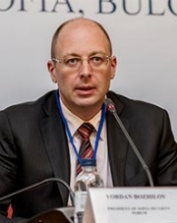
Yordan Bozhilov

President of Sofia Security Forum
Yordan Bozhilov was born on November 27, 1969. He holds a Master's degree in Political Science and a Master of Law. In 1992 he began his career in the Ministry of Defense of the Republic of Bulgaria. His professional career goes successively through all grades and positions. As an expert and senior expert he worked on the coordination of the Ministry of Defense with the other ministries and the Council of Ministers. He was subsequently appointed Chief of the Chancellery Department. As such, he managed the entire documentary work of the Ministry and was responsible for the development and implementation of a number of information systems. In 2002-2003, he completed a course at the Geneva Center for Security Policy. On his return he was appointed Chief of International Organizations and Arms Control Department of the Ministry of Defense. As such, he represented the Ministry of Defense in a number of international organizations. From 2005 to 2008, he was the Director of the International Cooperation Directorate, responsible for the bilateral relations of the Ministry of Defense and the participation of the Ministry in international organizations. He has led the negotiations and the conclusion of bilateral defense agreements. From 2008 until the beginning of 2010, he was the Deputy Director of the Defense Policy Directorate. Between 2005 and 2008 he represented Bulgaria in various NATO working groups. In 2008 he worked as Chairman of the Multinational Advisory Group of RACVIAK – Centre for Security Cooperation, Zagreb.
In the period 2010-2013 he served as Chief of the Cabinet of the Minister of Defense. Since 2013 he has been working as an analyst in the Bulgarian Academy of Sciences and is President of Sofia Security Forum, a non-governmental organization, working in the spheres of security, defense, international relations and the training of young leaders.

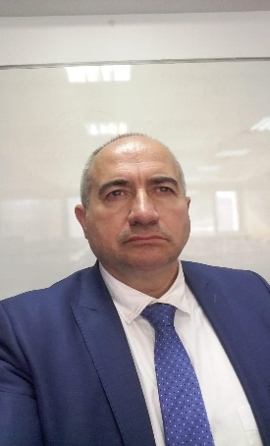
Georgi Krastev

1993-2003 National Security Service to the Ministry of Interior, later – State Agency for National Security.
2003-2006 - Director of the Security Directorate conducting the reliability studies at the State Commission on Information Security.
From 2006 to present - Administration of the Council of Ministers. Professional engagements - Integration policies for vulnerable communities; ethnic minorities; national security policies.

Currently, adviser to the Prime Minister's Political Cabinet; Secretary of the Security Council and Deputy Chair of the National Council for Cooperation on Ethnic and Integration Issues.

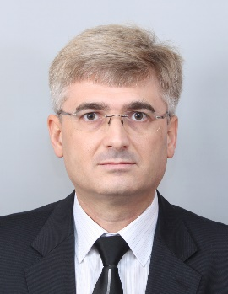
Col Nikolay Nikolov, PhD
Colonel Nikolay Veskov Nikolov was born on 17th Sep 1971. He holds a PhD in Mechanical Engineering. He is a Branch Head “Armaments Development” at Defence Acquisition Directorate at Ministry of Defence.
During Bulgarian Presidency of the Council of the EU2018 he played a key role as a chairman of the FoP “Friends of Presidency” and represent the Council for negotiation between European Commission, European Parliament and Council of the EU. EDIDP is a game changer for a Europen Defense, as an outcome last week European Commission launched “European Defence Industrial Development Programme” WoP.
Col. Nikolov is an armament expert, graduated class of 1994 from Artillery Military Scholl in Shumen. He has a long experience in defence industry, military professional training, and research institutes. From 2011 until 2013 he represented Bulgaria at NATO STO. For three years, Col Nikolov served as a concept development staff officer at NATO Allied Command Transformation, Norfolk,VA.
Col. Nikolov is PRINCE2 certified and completed a course at Defense Resource Management Institute at Naval Postgraduate School, Monterey, CA. He worked in a couple of projects related to arms control issues and non-proliferation.
Currently, he is a Deputy National Armaments Director and run the Armaments Council, Science and Development Programme at BGR MoD. In addition, he coordinates national EDIDP/EDF matters.

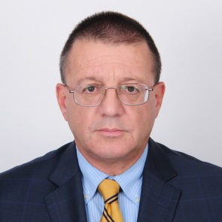
Ambassador Boyko Noev has served as Deputy Minister of Defense (1994) and Minister of Defense (1994-1995 and 1999-2001).

With an educational background in International Relations and years of experience as a diplomat on the international stage he was the Bulgarian Ambassador to NATO, Belgium and Luxembourg (1996-1999). During his diplomatic career at the Bulgarian Ministry of Foreign Affairs (1981-1999), Ambassador Noev was also member and deputy-head of the Bulgarian delegations to the OSCE and the Treaty on Conventional Armed Forces in Europe. He served as Director, Center for National Security Studies at the Ministry of Defense (1993). He is the author of many publications and media appearances and has affiliations with the NGO sector and consultancy entities.


Angel Naydenov (Minister of Defense 2013 – 2014)

Angel Naydenov was born September 28, 1958. He graduated from the "Vaptsarov" National Naval Academy – Varna, "Navigation" profile in 1981 and the "Rakovski" National Defense College - Sofia - "National Security and Defense" in 2015.
He has been a Mayor of Dimitrovgrad, District Governor of Haskovo District, Member of the Parliament. Chairman of the Defense Committee at the National Assembly 2005-08 and Minister of Defense of the Republic of Bulgaria 2013-14

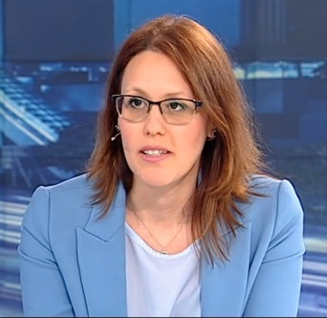
Monika Panayotova

CEO of Inno Advisers and Vice-President of Sofia Security Forum.
Monika is Former Deputy Minister for the Bulgarian Presidency of the Council of the EU2018 (ministre déléguée at European Parliament).
In 2014-2017 she was General manager of Inno Advisers, consultancy company developing innovative projects in education, health and science. Member of Horizon2020 Advisory Group, European Commission.
Previously she was Member of European Parliament (2012-2014): CONT, CULT and SEDE committees.
From 2009-2012 she was member of the Bulgarian Parliament, Chairwoman of Committee on European Affairs and Oversight of European Funds;member of Foreign Policy and Defence Committee.
From 2006-2008 Monika was research fellow&Projects and Public communications Director, Economic Policy Institute.
Monika holds PhD in Political Science, Bachelor in International relations and Master in International Economic Relations, University of National and World Economy Bulgaria.

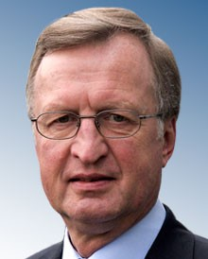
Heinrich Brauss

Former NATO Assistant Secretary General for Defence Policy & Planning

Heinrich Brauss was appointed Assistant Secretary General for Defence Policy and Planning on 4 October 2013, having joined the International Staff of the North Atlantic Treaty Organisation (NATO) in September 2007 as Deputy Assistant Secretary General for Policy and Planning.

Prior to joining NATO he served at the EU, first in the European Union Military Staff (EUMS) as Assistant Chief of Staff, Operations & Exercises Division and then as the Director of the Civilian/Military Cell and the EU Operations Centre.

In 2001, he assumed command of an Armoured Brigade in Potsdam/Germany. He also deployed for operations in Bosnia and Herzegovina, where he served as Chief of Staff in the Headquarters of the Stabilisation Force (SFOR). Other appointments included, inter alia, Chief of Staff of a Mechanised Infantry Brigade and Commander of an Armoured Artillery Battalion.

He first gained international experience as a member of the Staff of the German Military Representative in the Military Committee of NATO and EU/WEU in Brussels, where his responsibilities covered NATO's strategy, enlargement, command and force planning. He also served as Branch Chief in the Planning and Advisory Staff to the former German Minister of Defence, Volker Rühe, in Bonn/Germany.

Heinrich Brauss retired on 31 July 2018 after 46 years of service in the German Armed Forces. He holds the rank of Lieutenant General (retd.) in the German Armed Forces.

He is married and has three sons.
Contact:
heinrich.brauss@t-online.de
brauss@af.dgap.org
Mobile: +49 1778886891
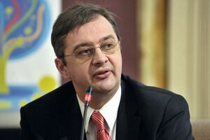
Iulian Chifu

Professor dr. Iulian Chifu is President of the Conflict Prevention and Early Warning Center Bucharest since 2014. He was Counsellor for Foreign, Security and Defence Policy for the President of the Romanian Chamber of Deputees between 2015-2016. Now he serves as Counsellor of the Romanian Senate since July 2016.

Mr. Chifu has been Presidential Counsellor for Strategic Affairs and International Security, Romanian Presidency, between 2012-2014 and Presidential Counsellor for Strategic Affairs, Security and Foreign Policy between 2011-2012.

Between May 2006 and October 2011 Mr. Chifu was Counsellor for Foreign, Security and Defence Policy for the Vicepresident of the Romanian Senate. Between July 2002 and September 2011 Iulian Chifu was Director at the Center for Conflict Prevention and Early Warning Romania. Between 2001 and 2002, Mr. Chifu was Director of the Center for Conflict Prevention, Academical Foundation for Black Sea, Bucureşti (Romania). Previously, between 1997 and 2001, he was Director for programs at the Group for Contemporary History Studies, Center for European History and Civilisation, Romanian Academy, Iaşi (Romania).

Mr. Iulian Chifu is specialised in Conflict Analysis, Crisis Decision-making and Post/Conflict Reconstruction, teaching at the Department International Relations and European Integration SNSPA, Bucureşti (Romania) since 2000. Since 2005, Mr. Chifu has been Associate Professor at the National Defence College, Bucureşti (Romania). Between 2007 and 2008, Mr. Chifu was Associate Professor National Academy for Information, Bucureşti (Romania). Between 2002 and 2007, Mr. Chifu was Scientific Secretary at the Department for International Relations, SNSPA, Bucureşti (Romania). Moreover, between 2002 and 2005 he was Associate professor at the Center for NATO Studies, Bucureşti (Romania).
Between 1998 and 2004, Mr. Chifu attended a PhD in History Science, Contemporary History Specialty, graduating with the thesis ,,Basarabia under Soviet occupation 1940-1941; 1944-1991", at University of Craiova, Romania. He had graduated in 1992 from University "A.I.Cuza", Iaşi (Romania), Faculty of Mathematics and Physics, Mathematics Section. Mr. Chifu attended post-university studies in International Relations at SNSPA Bucuresti between 1997 and 1999.
In August 2010, Mr. Chifu attended the International Visitors Leadership Program, Conflict Prevention at the US State Department, Washington (United States). In December 2006, Mr. Chifu attended the Senior Course on Crisis Management and Civil Emergency Planning at the Institute for National Defense and Security Policy Studies, Swedish National Defense College, Stockholm (Sweden). In May 2005, Mr. Chifu attended a graduate course in,,Intelligence and Civil Society" at the Center for Civil-Military Relations, Naval Post-Graduate School, Monterrey, California (United States).

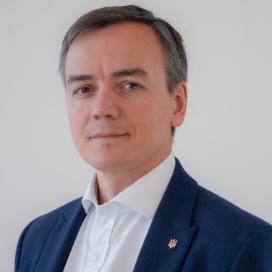
Oleksandr KHARA

Since April 2014 Oleksandr Khara is an expert of the Ukrainian foreign policy think tank Maidan of Foreign Affairs. Since 2017 he is a Deputy Chair of the Black Sea Institute of Strategic Studies.
In 2011 – 2014 he was an Executive Assistant to a Member of the Ukrainian Parliament.
Mr. Khara is a member of 2010 Royal College of Defence Studies’ course (London, UK).
In 2006-2008 he was a State expert, and in 2008-2011 — Deputy Director General for Foreign Affairs at the Office of the National Security and Defence Council of Ukraine.
Mr. Khara held a number of positions within the Foreign Ministry of Ukraine, including Department of the Americas (2000-2002, 2005-2006) and at the Embassy of Ukraine in Canada (2002-2005).
Oleksandr Khara has received his Master’s degree in Foreign Policy at the Diplomatic Academy of Ukraine (2000) and Bachelor’s degree in Economy and Management at the Donetsk State Academy of Management (1998).

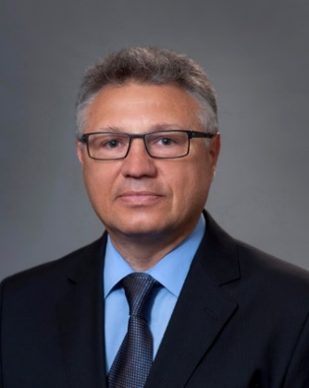
Velizar Shalamanov (minister of Defense 2014)

Deputy Director in Institute of Information and Communication Technologies of the Bulgarian Academy of Sciences on e-Infrastructure and security. Previously 2009-2017 working in the NCI Agency as Director Demand Management. In 2014 was a Minister of Defense and in the period 1998-2001 Deputy Minister of Defense. Has experience leading sector and section in Defense Institute and in the Bulgarian Academy of Sciences, Adviser to the Chairman of the Academy of Sciences.

Change management and IT governance / management specialist, combining governmental experience with sound theoretical knowledge and background in operations research and security studies; Specializing in security sector reform, primarily from organizational management perspective and use of IT; Considerable expertise in leading and participating in national and international research and change management teams.

Member of the Editorial Board of Information & Security: An International Journal, Chairman of George C. Marshall Association – Bulgaria, and member of the AFCEA Sofia chapter. Participates in the Consultative council on effective, efficient and cyber resilient management of IT resources to the Chairman of the Academy of Sciences and the Consultative council on institutional change management in the UNWE-Sofia.

